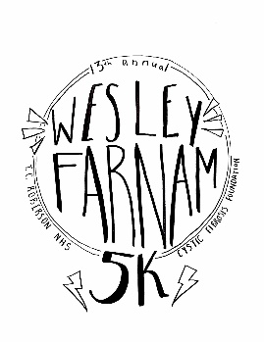
13th Annual Wesley Farnam 5k, May 8th, 2020

The Wesley Farnam 5k is an annual event put on by the Charles T. Koontz Chapter of the National Honor Society at TC Roberson High School. This event is help in honor of a former student living with Cystic Fibrosis. All proceeds raised are donated to The Cystic Fibrosis Foundation. There are typically close to 200 runners in this event and additional spectators. This race largely appeals to high school students in south Asheville and their families.
Opportunities for sponsorship include:
- Sponsorship of the 5k race (information below)
- Food/Beverage donations for post race refreshments
Community Partners of the Wesley Farnam 5k and businesses donating items or services to the event, of a value meeting the requirements below will receive the following:
 | Bronze ($50) | Silver ($100) | Gold ($250)
Your business’s logo and/or name receive placement in all our marketing material and promotional collateral (i.e signage) connected with this event | Name only | Name and Logo | Name and Logo in a prominent placement/font
Your business’s logo and/or name and a link to your business’s website will be displayed on the race’s website in connection with any announcements about this event | Name only | Name and Logo | Name and Logo in a prominent placement/font
Your business has the opportunity to place promotional materials in the reusable bags given to event attendees |  | X | X
The opportunity to have a promotional table at the event |  |  | X
Verbal recognition and Sponsorship Award presentation at event |  |  | X

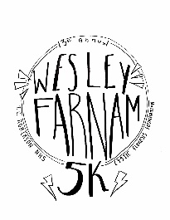
Partnership Agreement
250 Overlook Rd. Asheville NC 28803
Laura.ketchuck@bcsemail.org
https://wesleyfarnam5k.weebly.com/
*This form may be scanned and emailed to above email address or a hard copy may be turned in to TC Roberson High School

We would like to partner in the amount of:
□ $250+ □ $100 □ $50
We would like to food/beverage items for post-race refreshment:
□ Gift Certificate Value or In-kind Donation ____________________________________________________
□ Service Value (as determined by donor) ____________________________________________________
□ Donor Notes (if making a $100+ contribution do you plan to put promotional items in our race bag? If $250+ donation do you plan to set up a booth)_______________________________________________________________
PARTNER INFORMATION
Company: ________________________________________________________________
Authorized Representative: ________________________________________________________________
Address: ________________________________________________________________ Telephone:___________________
E-mail: __________________________________________________________
PAYMENT
□ Our check is enclosed or will be mailed to 250 Overlook Rd. Asheville NC 28803 payable to TCR NHS
Logo Information: Please email all logos to laura.ketchuck@bcsemail.org
*All promotional race bag items must be turned in by May 1st to TC Roberson High School

